**Control Systems Laboratory Experiment 3**

**Time Domain Analysis of a Second Order System**

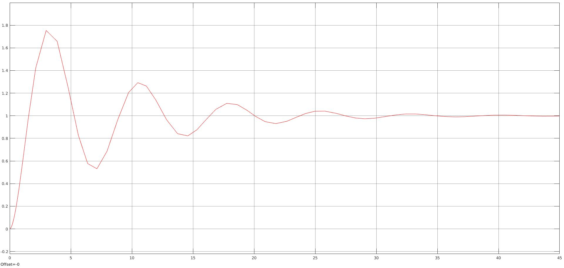

**1. Source Code**

% time domain analysis of second-order system

% 100

% G(s) = -----------------

% s^2 + 2s + 100

N = [100]; % numerator

D = [1 2 100]; % denominator

sys = tf(N,D);

% generate step response

step(sys);

% >>stepinfo(sys)

%

% struct with fields:

%

% RiseTime : 0.1127

% SettlingTime : 3.8373

% SettlingMin : 0.4685

% SettlingMax : 1.7292

% Overshoot : 72.9156

% Undershoot : 0

% Peak : 1.7292

% PeakTime : 0.3142

**2. Block Diagram**

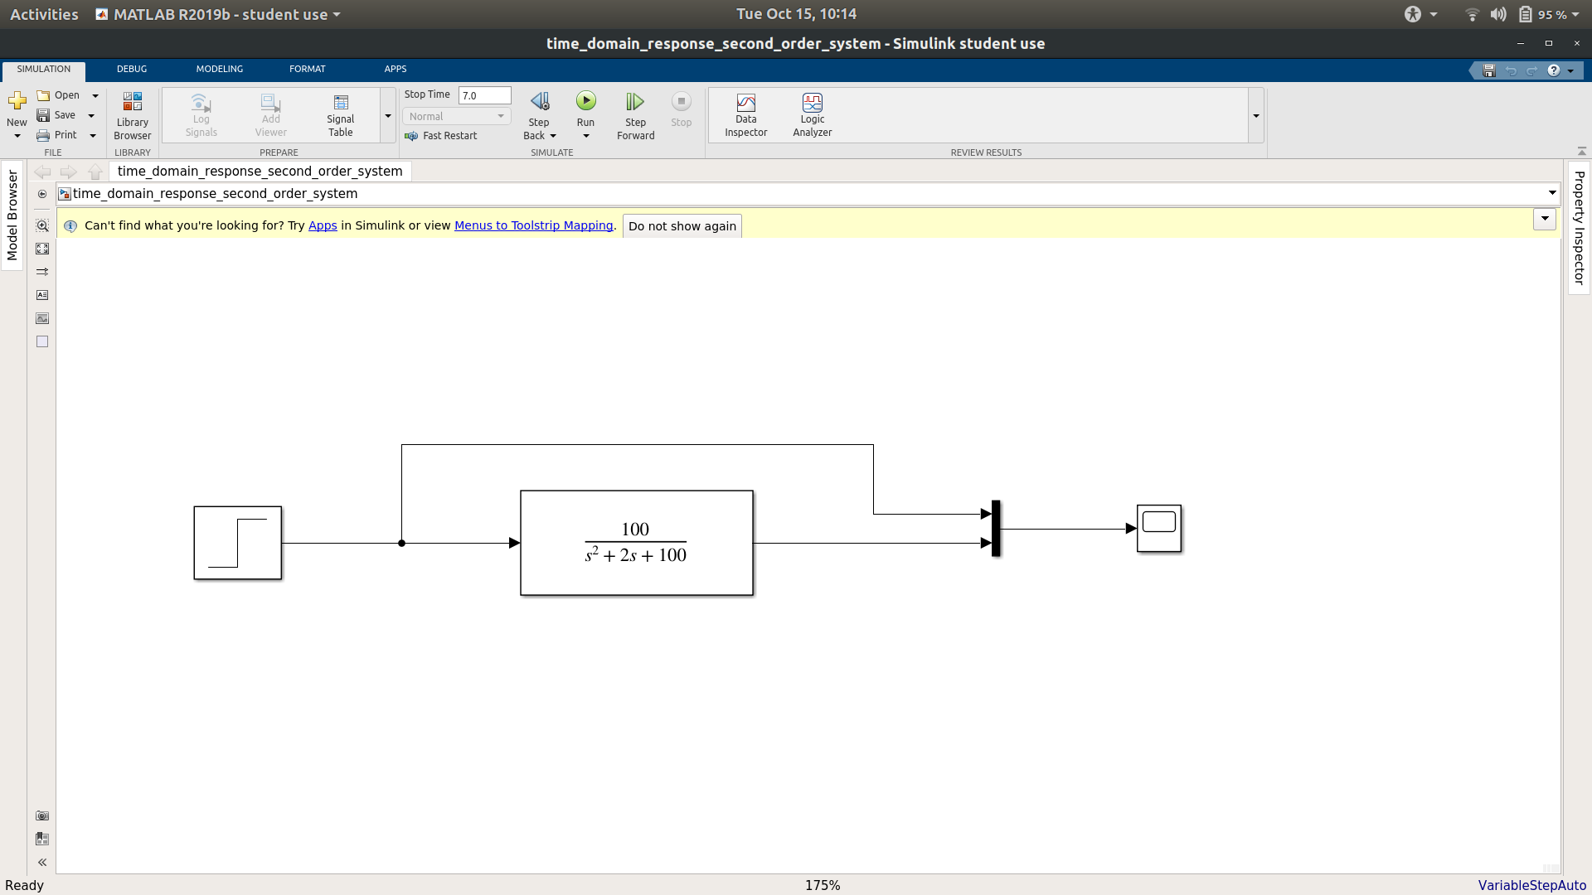

**3. Time domain Response**

